**Restaurant Management System**

**Draft 2**

**May 15, 2019**



**RMS Team:**

Eneida Berisha  
Erblin Zekthi

Kei Vrapi

Visara Krrashi

Xheni Sollaku

# User Scenarios/Use Cases

|  |  |  |
| --- | --- | --- |
| Number | User scenario name | Description |
| 1 | Employee Login | Using a username and password combination to access the system |
| 2 | Admin Register new employee | Adding a new employee that starts working |
| 3 | Admin Edit Employee | The currently registered employee credentials can be edited and updated |
| 4 | Admin Delete Employee | In case an employee is removed from the job his status can be deleted |
| 5 | Admin Login Function | Using the admin username and password the system administrator can login and access the employees’ data |
| 6 | Waiter Add Order | The waiter is able to add an order from the Products list of the currently opened tab |
| 7 | Waiter Open Tab | The waiter can open a new tab for a specific table to add newly purchased products from the bar. |
| 8 | Waiter Prints Tab | The currently opened tab is sent to the computer’s printer to be printed |
| 9 | Waiter Delete Order | The waiter is able to remove an order from the Products list of the currently opened tab |
| 10 | Bartender confirm tab | The bartender is able to confirm an order when he has prepared it and the notification goes directly to the waiter. |
| 11 | Cooker confirm tab | The cooker is able to confirm his preparation when he has prepared it and the notification goes directly to the chef. |
| 12 | Cooker edit function | The cooker is able to edit the products available of his section and when the product is low on stock the notification goes directly to the chef |
| 13 | Chef cooker confirm tab | The chef is able to confirm an order when it is prepared on the kitchen and the notification goes directly to the waiter. |
| 14 | Chef cooker products section | Chef has listed all the products available in the restaurant and he creates the report about the stock in the end of his shift and send it to the admin |
| 15 | Log out | Provide the user to logout from the system |
| 16 | Employee Login Fail | If the username and password  combination doesn’t match up in the Database, then the user cannot log in. |
| 17 | Print Empty Tab Exception | The system returns an Error pop-up with the exception description that a currently empty tab cannot be printed without any products in it. |
| 18 | Admin Add Product | The currently logged in administrator (manager or owner) is able to add a new Product with all the product info specifications and update the database so the new product can be accessed by every employee |
| 19 | Admin Approve delivery of Supplier | The admin should also be able to confirm a new supplies’ delivery when he has successfully received the order from the supplier |
| 20 | Admin Delete Product | The currently logged in administrator is able to delete a current existing Product and the system will update the database. |
| 21 | Admin Edit Product | The currently logged in administrator is able to edit Product info specifications and update the database so that the new product can be accessed by every employee |
| 22 | Supplier Add Delivery | The currently logged in supplier should be able to upload new order credentials and alert an administrator with the status of this order. |
| 23 | Supplier Login | Using the supplier username and password the supplier can login and access the order. |
| 24 | Admin Add Category | The currently logged in administrator is able to add a new Category accompanied by a count number and validity cell |
| 25 | Admin Tables Update | The administrator should be able to add/update/remove Tables from the database, so they can be accessible by the employees. The tables will contain a unique code. |
| 26 | Employee Change Password | The currently logged in employee should be able to change his password (according to some predefined constraints), and store the new password in the database. |
| 27 | Employee End Work Day | The currently logged in employee should be able to close his working shift and save everything. |
| 28 | Waiter Products List | The Waiter must be able to access an updated Products list, divided into categories and each with its respective price. All accessible within the waiter interface. |
| 29 | Admin Reports Review | The logged in administrator should be able to review reports on the daily sales. Firstly the reports view should collect and show all the cumulative daily reports and their totals, then there should also be a button to expand a specific report with more details. |
| 30 | Bartender Bar Details | The bartender should be able to add/update Bar Details which can optionally be shown into the printed receipt. |
| 31 | Waiter Transfer Tab | In the case of an incorrect Tab to Table assignment, the waiter should be able to transfer this still opened tab to the correct table without losing time/date information and without the need to delete/create a new tab. |
| 32 | Accountant Review Tab | In the end of its shift, the accountant should have the access on all the transactions made during the day and gathers all the data needed for his report. |

State Diagrams

State user

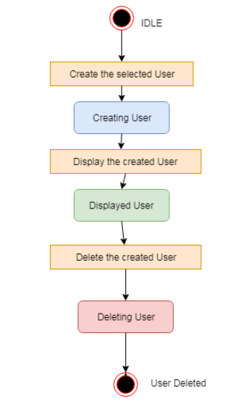

State product

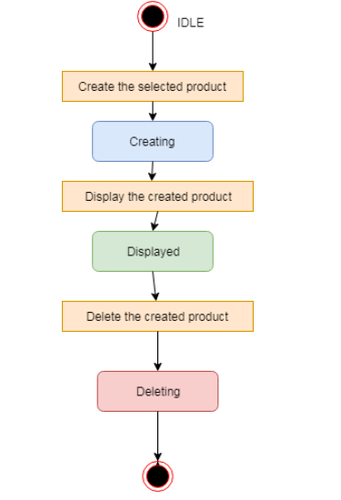

State Tab

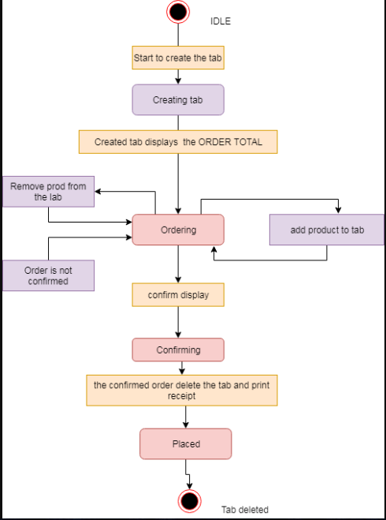Activity Diagram

User Add Product

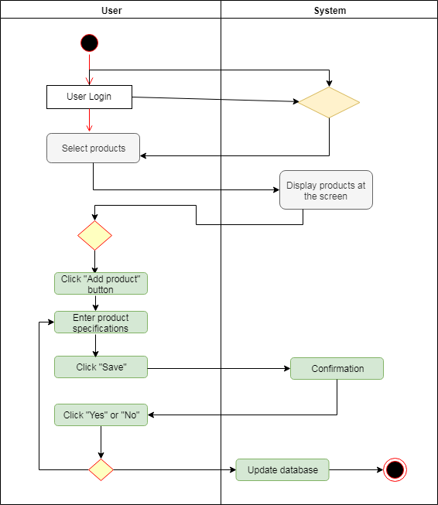

User Edit Product

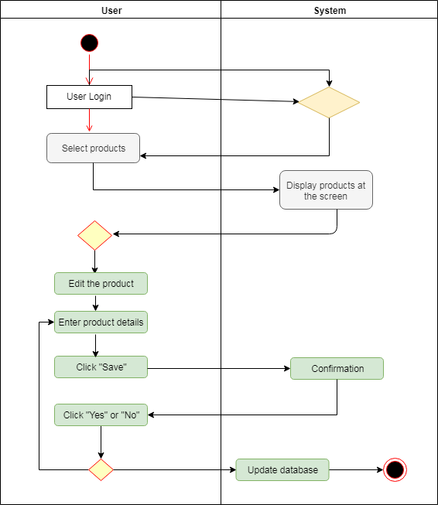

User Deletes Product

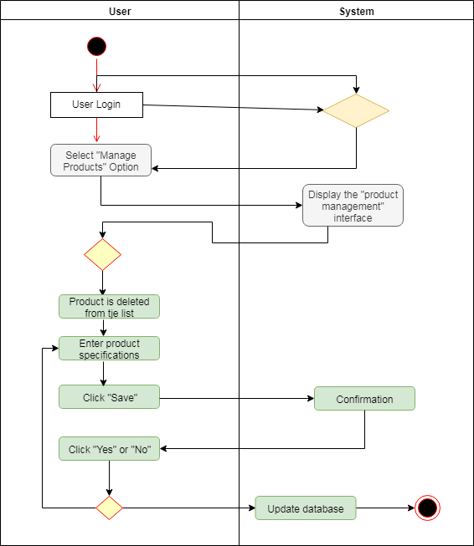

User Approve Delivery

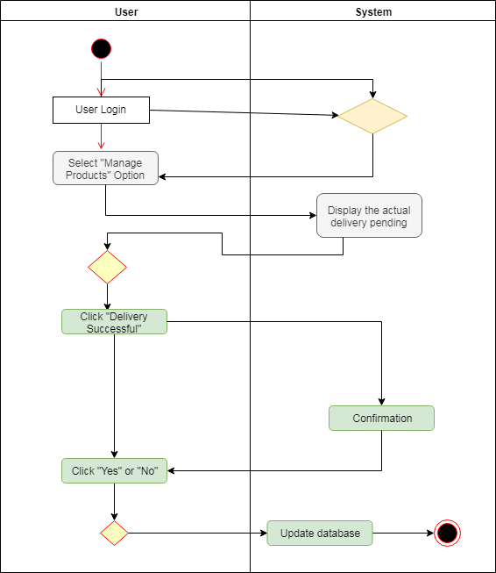

User End Shift

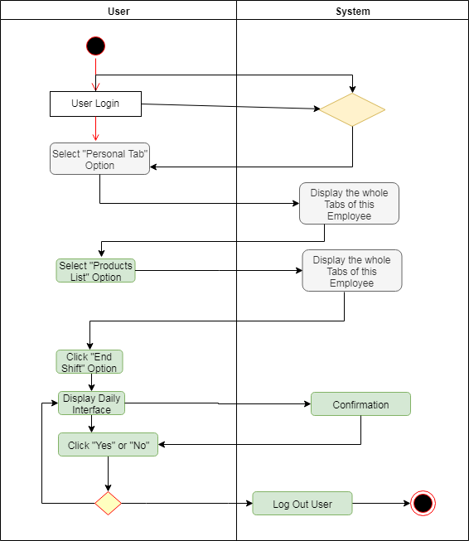

User Add Category

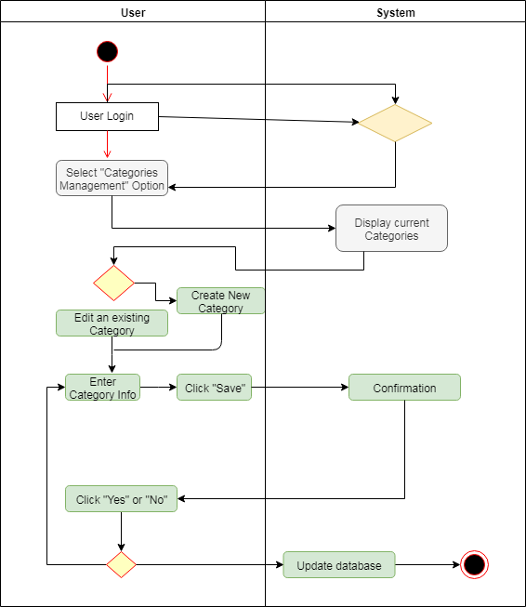

User Reports

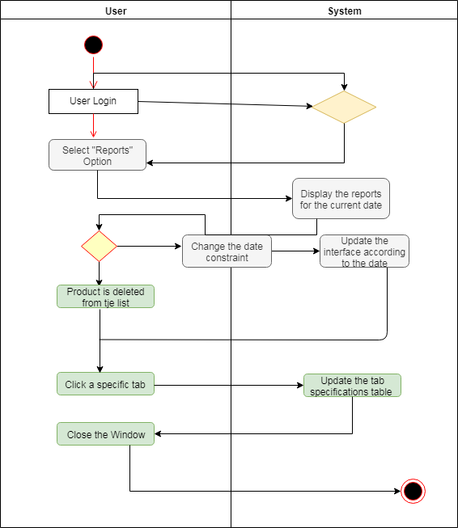

Administrator Add User

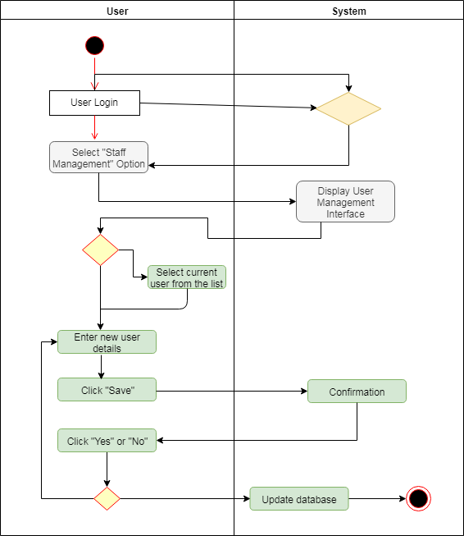

Supplier Approval

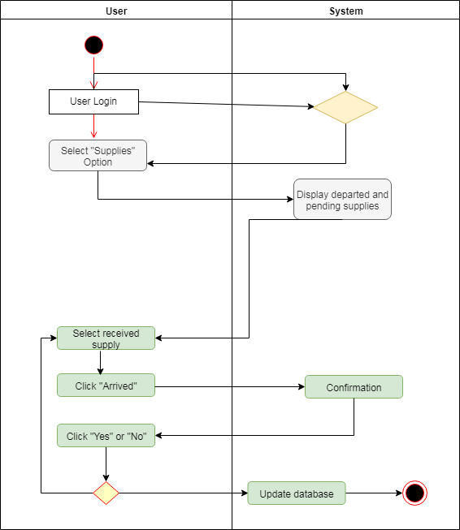

Sales Process 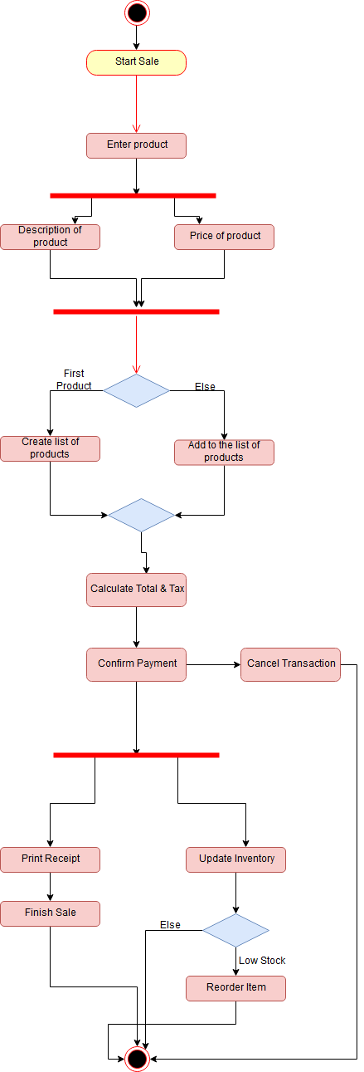

User Delete

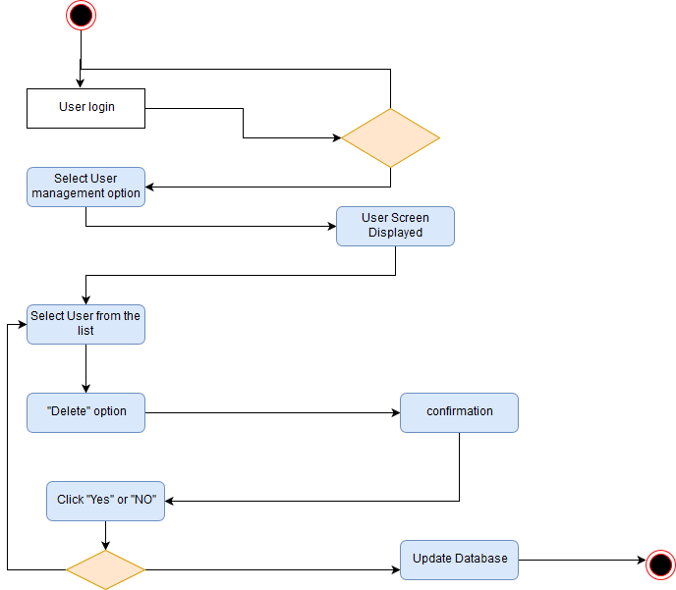

Transfer Tab

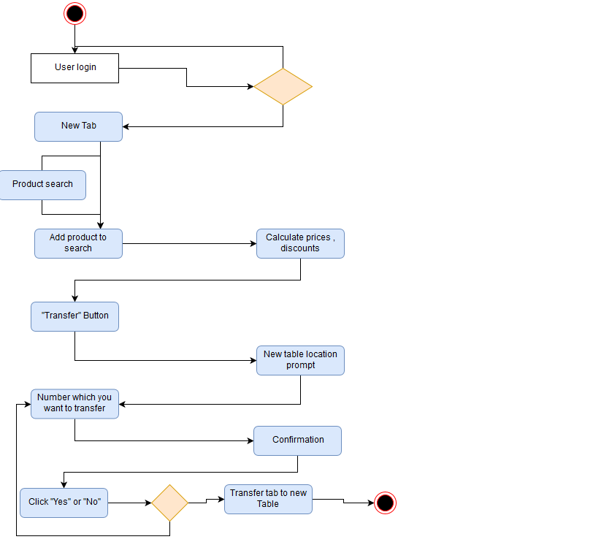

Supplier Add Delivery

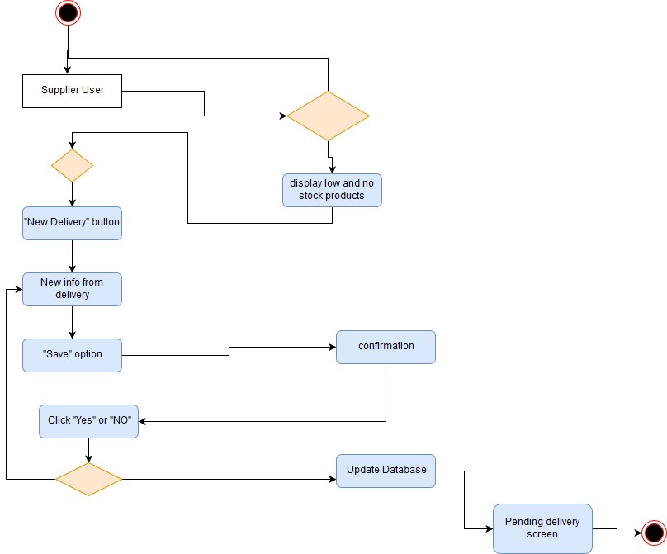

Sales Activity

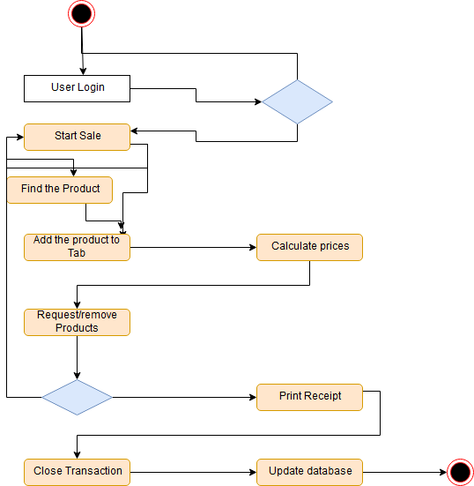

Sequence Diagrams

Admin Process

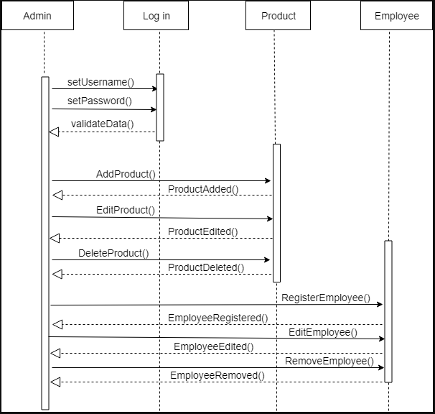

Accountant Process

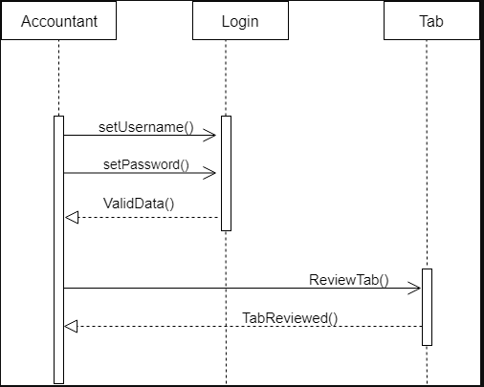

Bartender Process

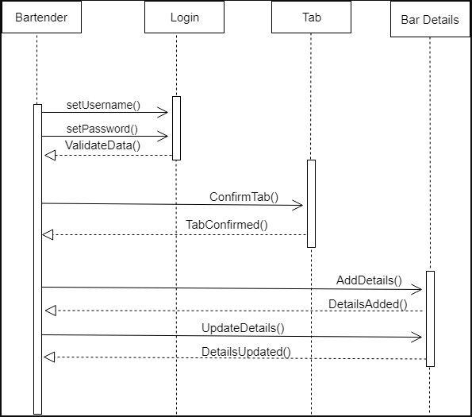

Cooker Process

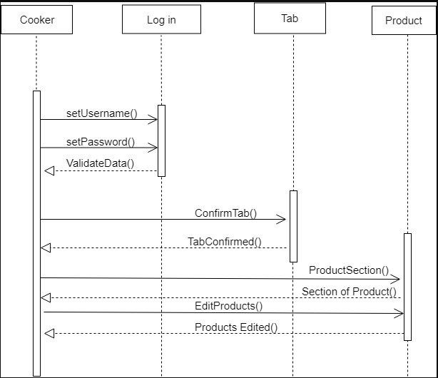

Employee Process

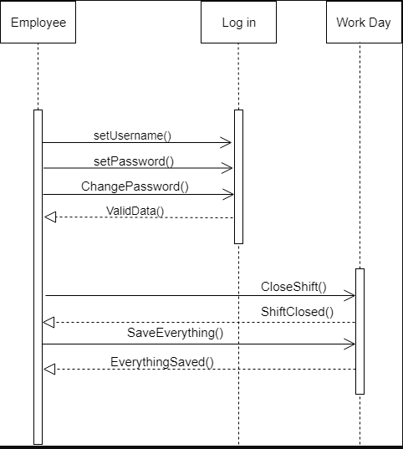

Supplier Process

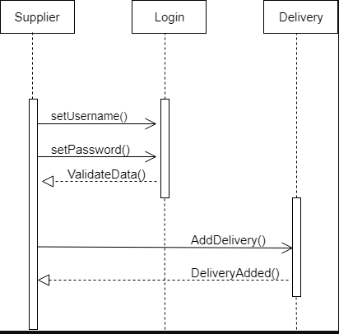

Waiter Process

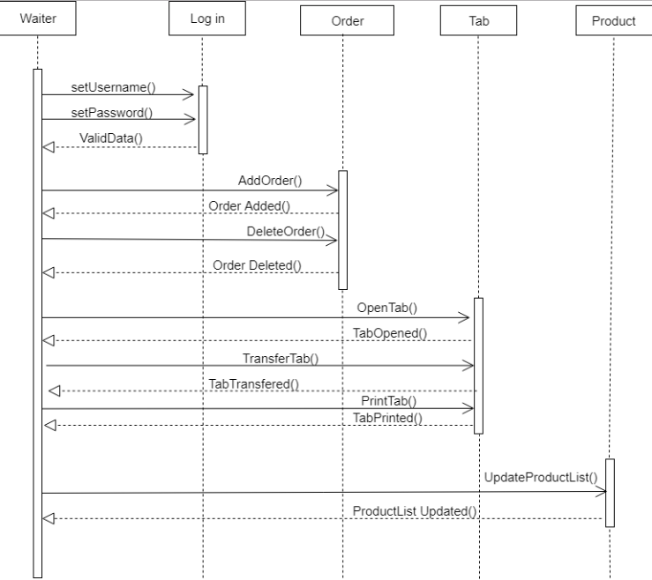

Collaboration Diagrams

Client order

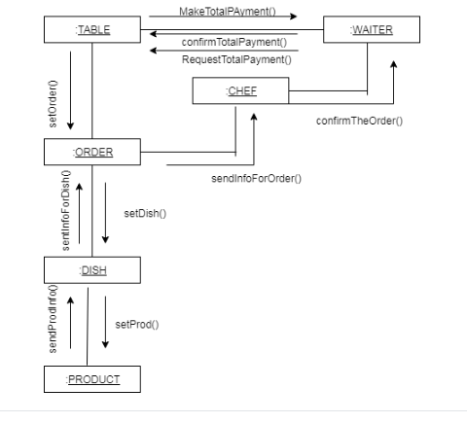

Products from suppliers

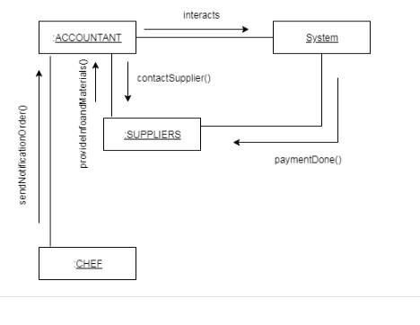

System and orders

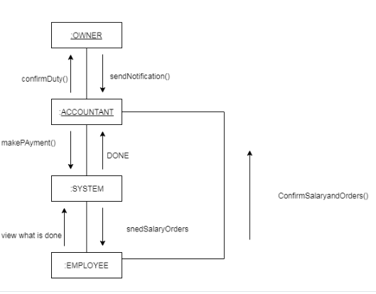

Object Diagrams

Accountant supplier product transaction

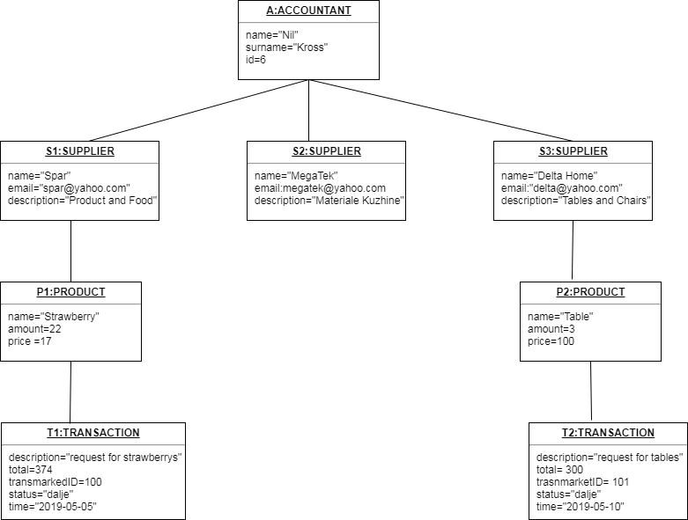

Order chef

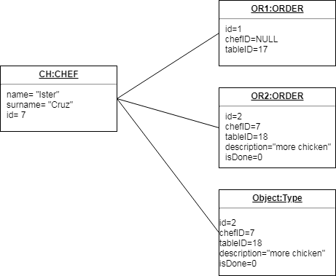

Order waiter

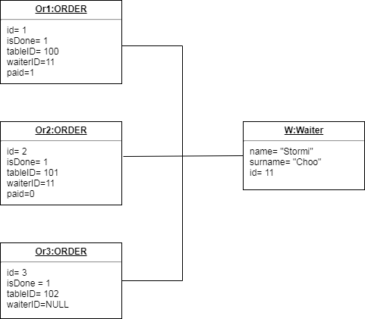

Owner

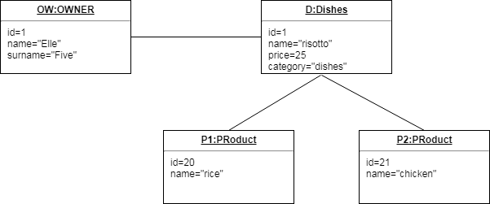

People working

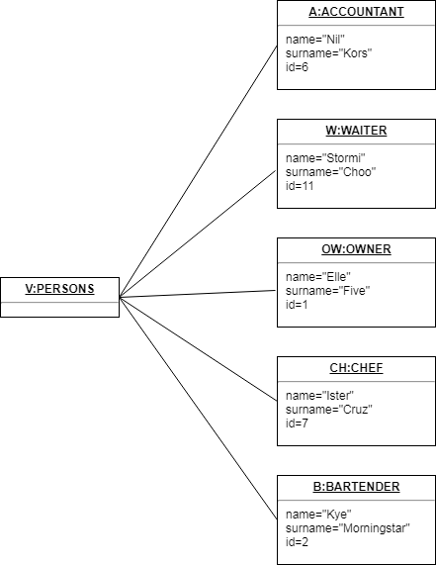

Products and accountant

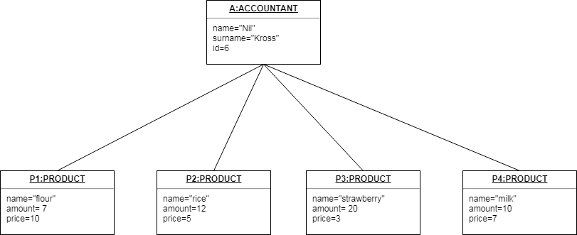

Salary and employee

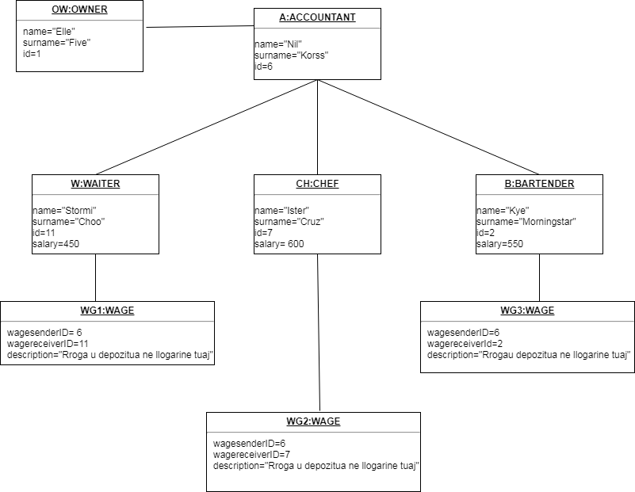

Table waiter

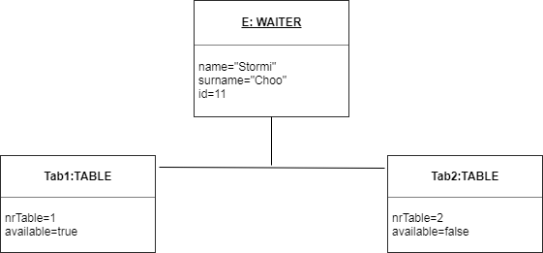

Table order

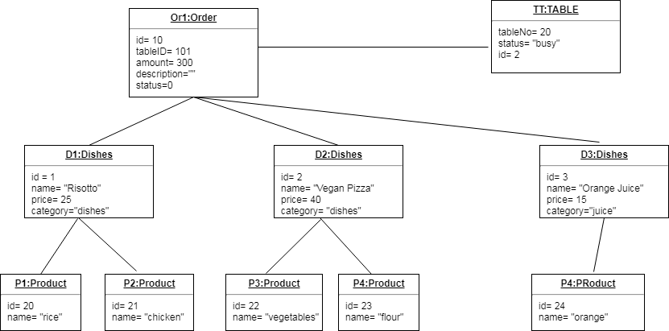

Data Flow Diagrams

DFD (level0)

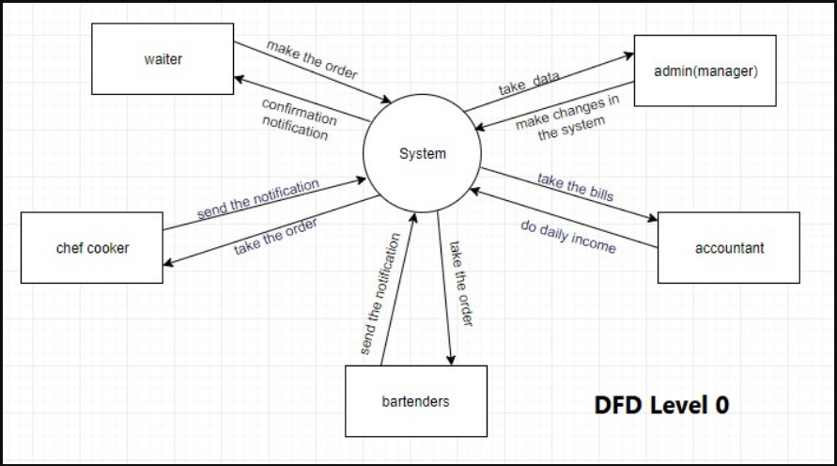

DFD (level 1)

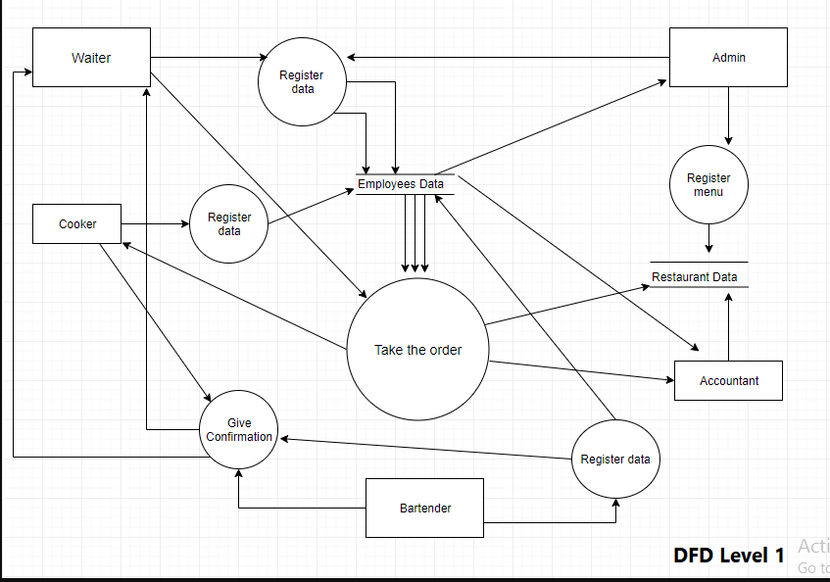

DFD (level 2)

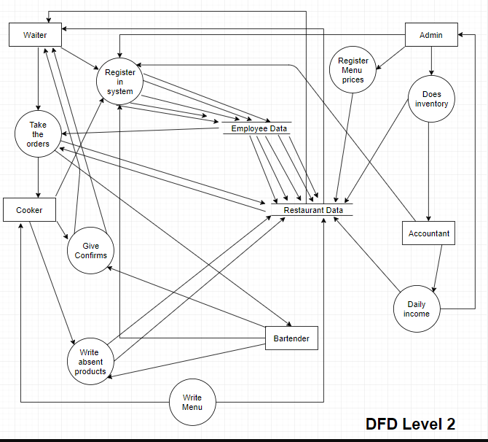

DFD (level 3)

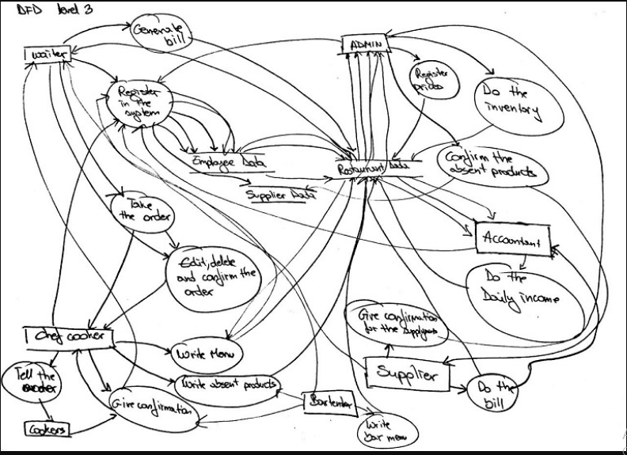

DFD (level 4)

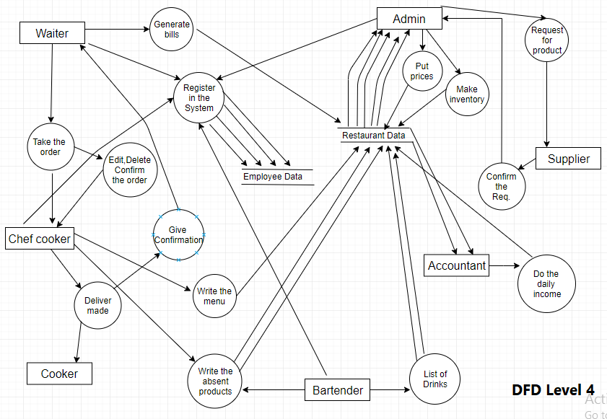

Class Diagram

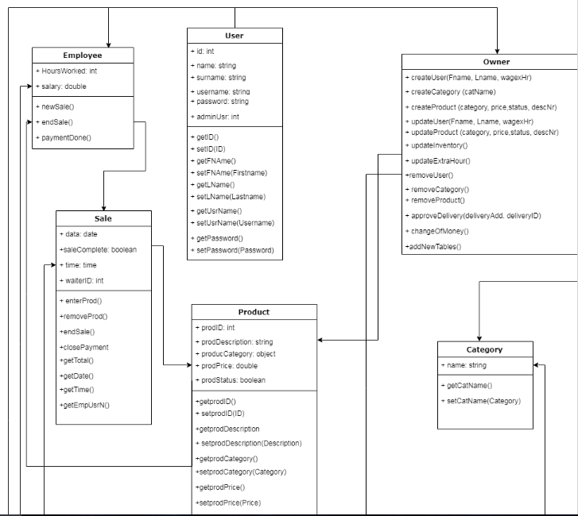

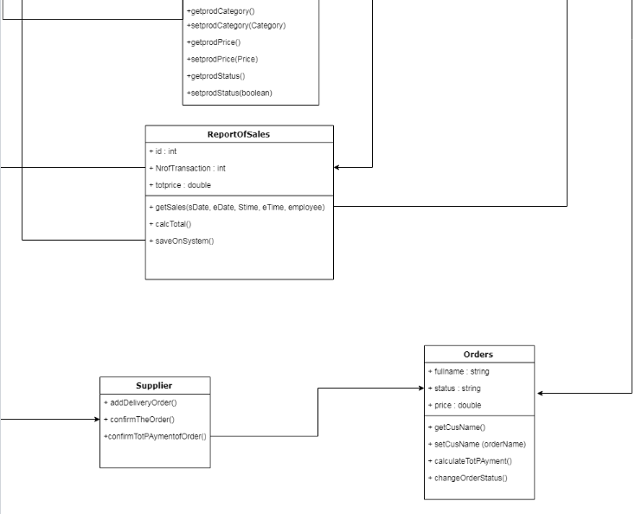

ERD diagram

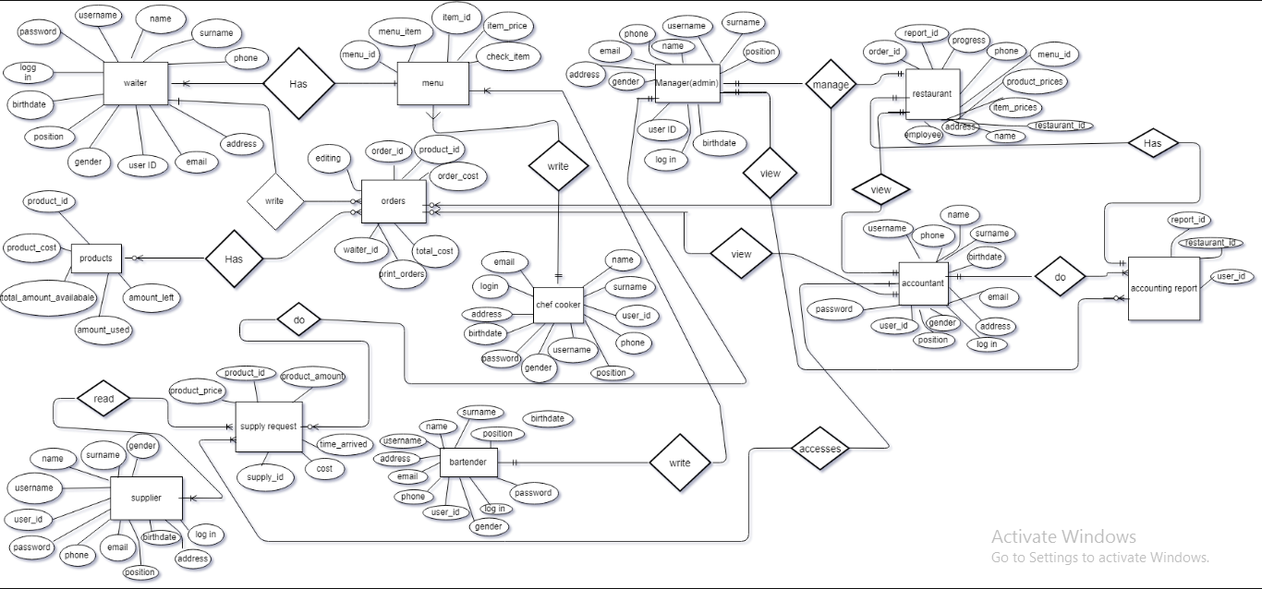

Component Diagram

